# **Create an A4 Flyer using the existing setup of the A3 Flyer**

Login to **Admin**, go to **Products**, **View All**, and **Search A3 Flyers**, **select** the Product, Click **Action** and **Duplicate Product.**

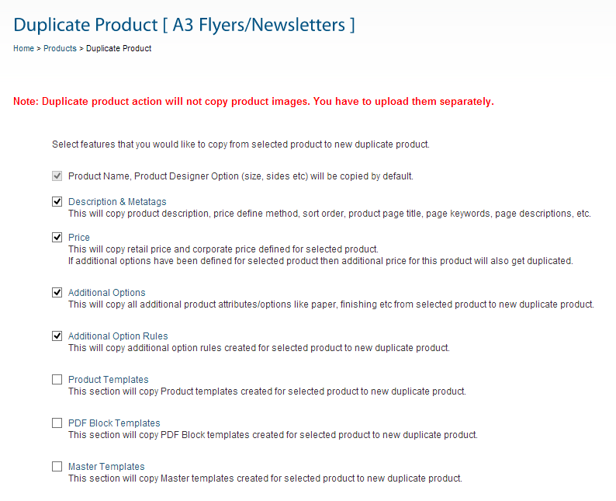

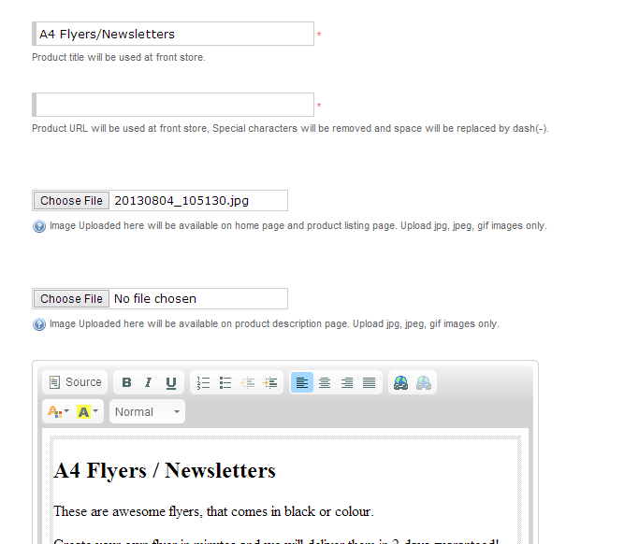

**Change the Text to A4 from A3…the image can be changed here but I chose not to.**

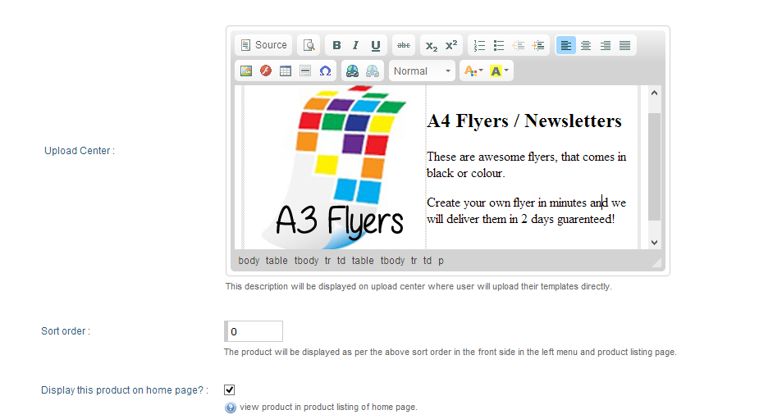

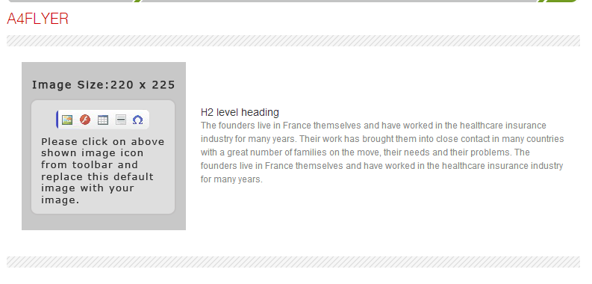**Apply multiplication pricing method for specific ranges, will set as a corporate price, just for Hema.**

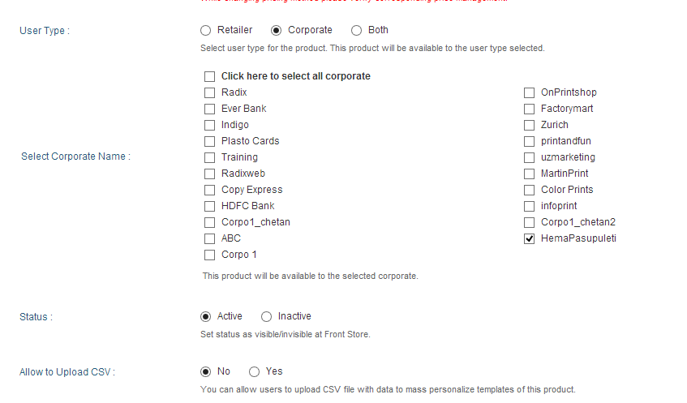

**Click Save and Continue**

**Save and switch to set Corporate Price**

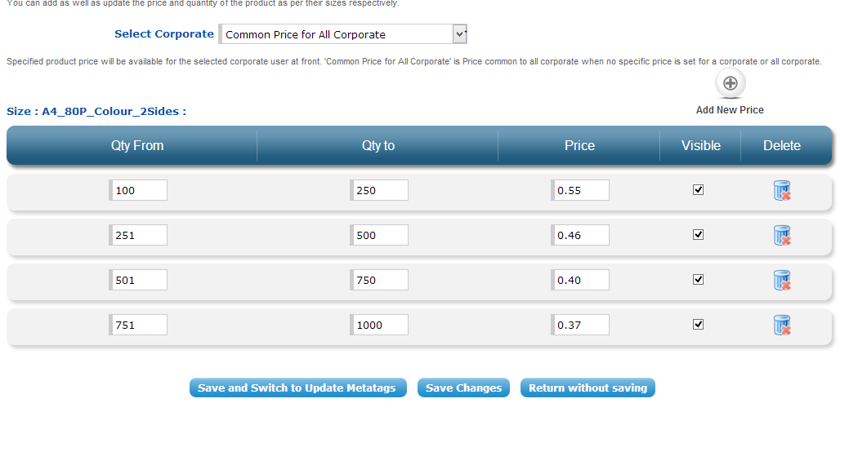

I’m not sure if this is the set price or multiplied price, assuming it is the multiplied price as that is what I said I wanted. Even if it is, the prices will only match Copy Express’s on the 250, 500 and 1000 orders; the price of 251 orders would be $115.46 which is cheaper than the $137 for 250. This method would not be suitable to Copy Express. The best option would be to set the number to be ordered and give a set pre-calculated price. When testing the A4 Flyer on the Corporate Website, it wouldn’t load…ops! But it did on the public site.

**Price testing:**

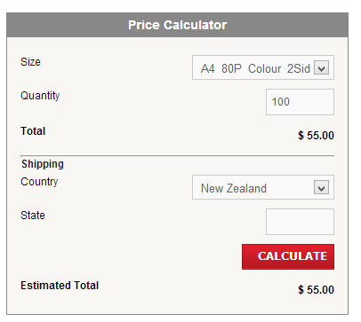 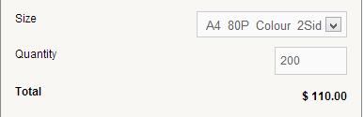 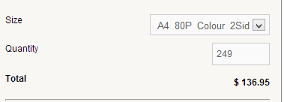

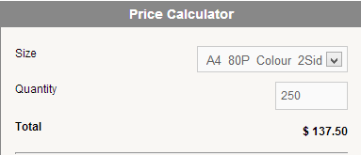 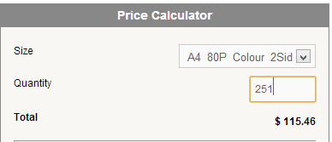 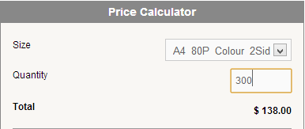

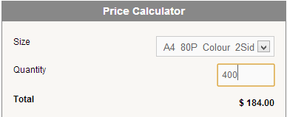 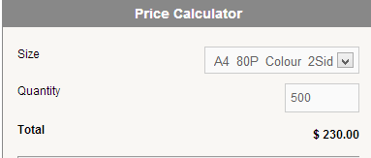 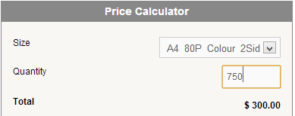

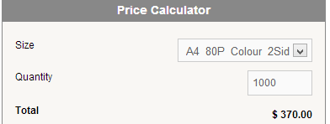 As Expected this style of pricing is **not** suitable

|  |  |  |
| --- | --- | --- |
| Quantity Ordered | Price Using the Copy Express Calculator | Price Returned using Ranges entered in the OnPrintShop multiplication pricing method |
| 100 | $82.40 | $55.00 |
| 200 | $118.80 | $110.00 |
| 250 | $137.00 | $137.50 (Slight error due to rounding) |
| 251 | $137.36 | $115.46 |
| 300 | $155.20 | $138.00 |
| 400 | $191.60 | $184.00 |
| 500 | $228.00 | $230.00(Slight error due to rounding) |
| 750 | $299.00 | $300.00 |
| 1000 | $370.00 | $370.00 |

**Works OK over 500**

### Email sent to OnPrintShop

1. *With the package we have been looking at, can the Sales Order Detailed report be customised to show which customers have paid and which are on-account (probably corporate) 20th of the month payment customers? If it can’t be customised like this then what sort of cost would this type of customisation be? (Please include providing each item in one order on a separate row in the report). We just want an idea of cost, we don’t expect an actual quote. *E.g. Customisations start at $500….\**

**OnPrintShop:** It is already available with our solution, you can filter each report as per the status like paid or on-account. So you will get report of that.   
As I mentioned in previous mail, in Subscription solution each item in one order cannot be in a separate row. We can customize this in Platinum License solution.

2. *Can a customisation be done to add a complex pricing and discounting system to the admin? This would calculate prices by quantity, product type, colour or black and white, single or double sided and type of paper and card used. It would not need to be entered for every product, but rather the product linked to a pricing schedule? This would also allow for a discount to be applied to certain customers without re-creating the same products at different prices. Again if it is possible, what sort of costs is it likely to incur?*  
**OnPrintShop:** This feature is already available in our solution. We do not have to do customization.   
- You can put the additional information for a product like color or Black & white, Type of paper, Turnaround, etc with different pricing. Kindly see Price Calculator in the following link: <http://salesdemo.onprintshop.com/en/business-cards-1/>

- For single and double sided, you have to provide two different products. Kindly see the following reference website: <http://www.artandprintshop.com/>  
- You can create customer specific discounts from Coupons/Discount section in Orders Management.

<http://www.artandprintshop.com/>  
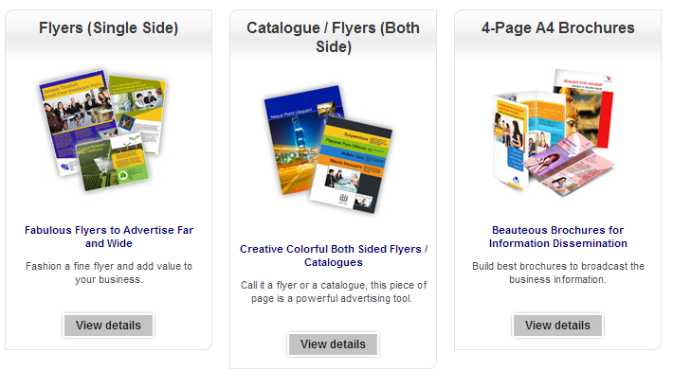

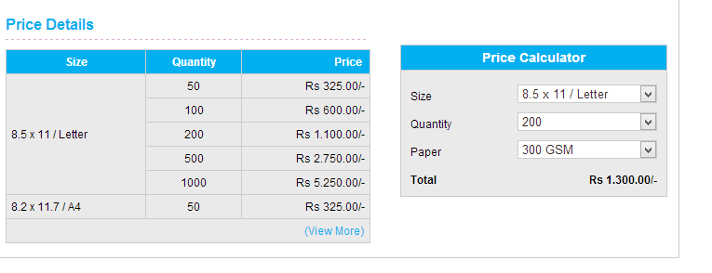

### Setting up and applying a coupon discount

Admin/Orders/Coupons Discount

<http://salesdemo.onprintshop.com/admin/coupon_listing.php>

Click Add Coupon or Discount

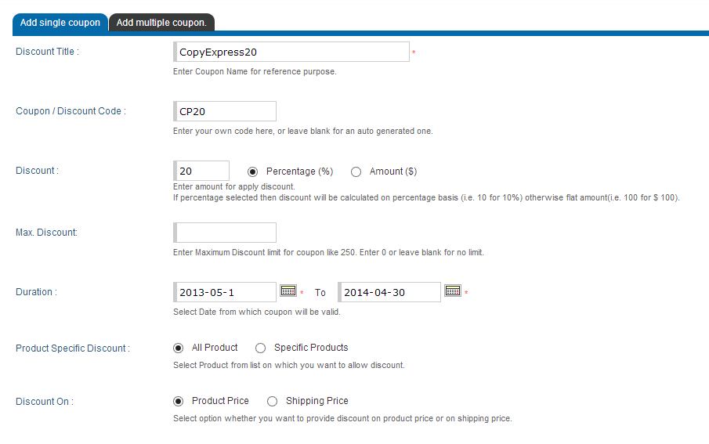

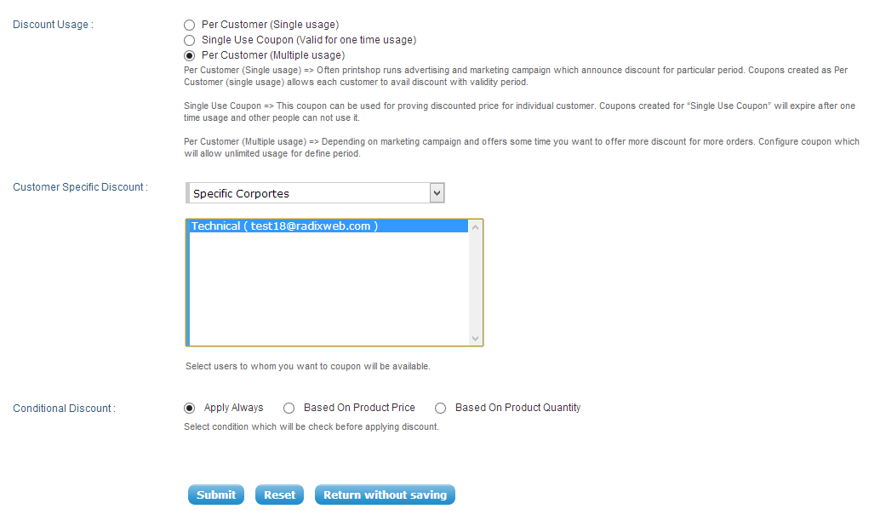

**Set To a specific Corporate or all Corporates all Retailers or Specific Retailers**

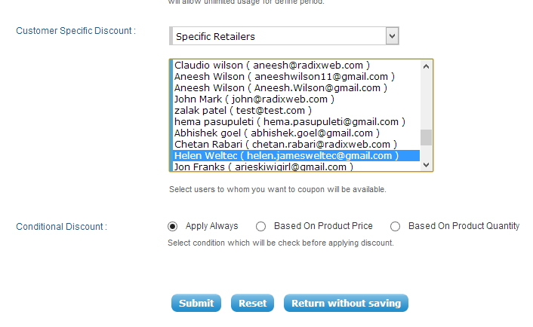

**Can only add one specific retailer at once but can easily duplicate the coupon to allocate to someone else.**

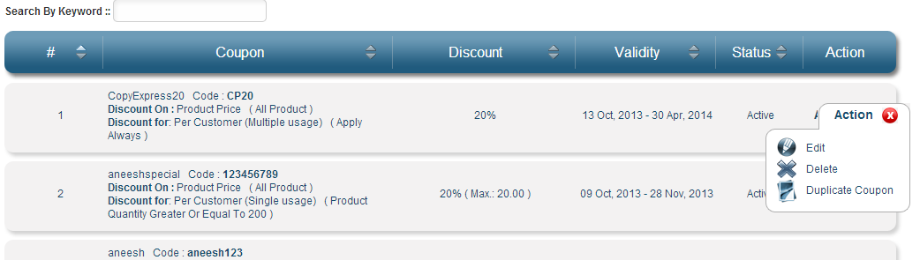

**Login to use the coupon**

Enter the coupon code, click redeem, the price is adjusted- Need to add every time you place an order but not for every product within the order…i.e. at checkout.

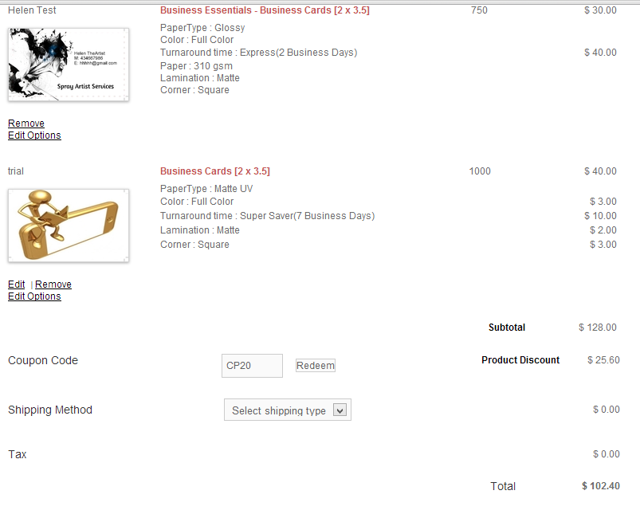

### Settings for download files

<http://salesdemo.onprintshop.com/admin/export_orders_settings.php>

Export Style :

With single file for all order, you can download all the orders in one csv/xml file, with selected fields below.  
With separate files per order, you can download zip file with separate csv/xml file per order. If there are multiple products per order, all products for the order will be added in single file.

Export File Name Format :

Variables : {orders_id}, {user_id}, {order_date}, {order_time}, {order_status}, {random}, {export_date}, {export_time}  
For single file mode, suggested file name is : orders_{export_date}_{export_time}  
For separate file mode, suggested file name is : orders_{orders_id}_{order_date}_{order_time}  
{random} variable will be replaced with random numeric string.

Export Format : CSV or XML

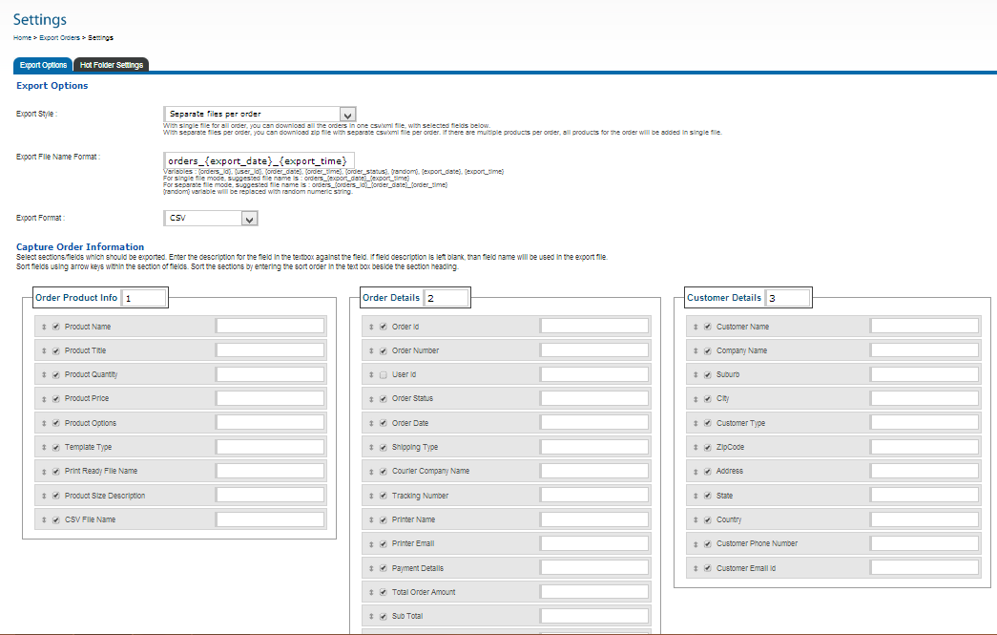

**Separated Orders can have the order number appended to the individual download files but not the folder.**

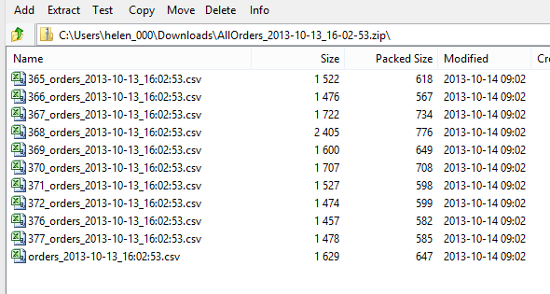

**Combined orders theoretically can have the order_ID appended, but it didn’t work**



**Filtering the unpaid Orders for download**

<http://salesdemo.onprintshop.com/admin/pending_order_listing.php>

Admin/Orders/Unpaid Orders/export

